Innovation of Breadfruit Flour-Based Brookies: Formulation Development and Consumer Acceptance
Made Ananda Diva Parameswara¹, Ni Luh Kartini², Ira Mayasari^{3*}
^{1,2,3}Diploma 3 Culinary Arts Study Program, Politeknik Internasional Bali, Indonesia
*Corresponding Author : ira.mayasari079@gmail.com

Abstract: The increasing demand for innovative bakery products based on local food resources encourages the development of alternative flour to reduce dependence on imported wheat flour. Breadfruit (Artocarpus altilis) flour has considerable potential as a gluten-free local ingredient because it is rich in dietary fiber and widely available in Indonesia. This study aimed to develop a breadfruit flour-based brookies formulation and evaluate consumer acceptance based on sensory attributes. The research employed a Research and Development (R&D) approach using the Four-D (Define, Design, Develop, and Disseminate) model combined with descriptive quantitative analysis. Product development consisted of formulation trials followed by hedonic evaluation involving 35 untrained panelists. Consumer acceptance was assessed using a five-point hedonic scale covering color, aroma, taste, and texture. The collected data were analyzed using descriptive statistics and percentage analysis. The results showed that the developed breadfruit flour brookies were well accepted by the panelists. Taste obtained the highest acceptance score (80%), followed by color (76.6%), while aroma and texture each achieved 74.3%, indicating that all sensory attributes were categorized as "liked." The product exhibited a dark brown appearance, a balanced chocolate aroma with a subtle breadfruit note, a pleasant sweet chocolate flavor, and a crispy texture. These findings demonstrate that breadfruit flour can be utilized successfully as a local alternative ingredient in modern bakery products without reducing consumer acceptance. The developed brookies offer an innovative approach to promoting local food diversification while supporting the development of value-added culinary products.
Keywords: breadfruit flour, brookies, consumer acceptance, local food, sensory evaluation.
History Article: Submitted: 13 July 2026 | Review: 14 July 2026 | Revised: 17 July 2026 | Accepted: 18 July 2026| Published: 30 October 2026

Introduction
The bakery industry has experienced significant growth in recent years, driven by increasing consumer demand for innovative products that combine attractive sensory characteristics with nutritional value. Among various bakery products, brownies and cookies remain highly popular because of their distinctive taste, texture, and versatility for product development. The emergence of hybrid bakery products has encouraged the combination of these two products into brookies, a dessert that integrates the moist and fudgy characteristics of brownies with the crispy texture of cookies. This product has attracted considerable attention because it offers a unique eating experience while creating opportunities for product diversification in the modern culinary industry.
Along with the development of innovative bakery products, the utilization of local food resources has become an important issue in supporting sustainable food systems. Indonesia possesses abundant local agricultural commodities with the potential to substitute imported wheat flour, yet their utilization remains relatively limited. Wheat flour continues to dominate bakery production despite being entirely dependent on imports. This condition encourages the exploration of indigenous food materials that can reduce import dependency while increasing the economic value of local commodities. Food diversification based on local resources has therefore become one of the strategic approaches to strengthening national food security and promoting sustainable culinary development.
Breadfruit (Artocarpus altilis) is one of Indonesia's local food commodities with considerable potential for further development. Besides being widely cultivated in many regions, breadfruit contains complex carbohydrates, dietary fiber, vitamins, minerals, and is naturally gluten-free, making it suitable as an alternative ingredient in bakery products. Previous studies have demonstrated that breadfruit flour possesses favorable functional properties, including adequate water absorption capacity, relatively neutral flavor, and good compatibility with various food formulations. These characteristics make breadfruit flour a promising ingredient for developing innovative bakery products while simultaneously enhancing the utilization of local food resources.
Several previous studies have investigated the application of breadfruit flour in bakery products. Aprilia et al. (2021) reported that breadfruit flour substitution significantly affected the organoleptic properties of steamed sponge cake, particularly in aroma, taste, and crumb structure. Mayer et al. (2024) also found that breadfruit flour could be successfully incorporated into steamed brownies, although high substitution levels tended to reduce consumer preference because of the characteristic aroma of breadfruit. Meanwhile, Suhendri et al. (2022) demonstrated that gluten-free brownies developed from modified cassava flour produced acceptable sensory quality and could serve as alternative bakery products. Research conducted by Muniroh and Hasanah (2024) further confirmed that gluten-free cookies formulated from local flour exhibited favorable consumer acceptance. Although these studies highlight the feasibility of utilizing local flour in bakery products, they primarily focus on brownies, cookies, or steamed bakery products separately.
Although previous studies have demonstrated the feasibility of incorporating breadfruit flour into conventional bakery products such as cakes, brownies, and cookies, limited attention has been given to the development of hybrid bakery products that combine different textural characteristics into a single formulation. Existing studies have mainly focused on flour substitution and consumer acceptance without addressing how breadfruit flour performs in more complex bakery matrices requiring both brownie-like softness and cookie-like crispness simultaneously. Consequently, scientific evidence regarding the suitability of breadfruit flour for hybrid bakery formulations remains limited.
Therefore, this study proposes a novel gluten-free brookies formulation based primarily on breadfruit (Artocarpus altilis) flour as a locally available Indonesian food resource. Unlike previous studies that investigated breadfruit flour only in conventional bakery products, this research develops a hybrid bakery formulation integrating the sensory characteristics of brownies and cookies while demonstrating the feasibility of using breadfruit flour as the main flour component. The proposed formulation contributes to food science by providing a formulation model for gluten-free hybrid bakery products based on local food resources while enhancing the added value of breadfruit as an indigenous Indonesian commodity. Accordingly, this study aims to develop a breadfruit flour-based brookies formulation and evaluate consumer acceptance based on color, aroma, taste, and texture. The findings are expected to provide scientific evidence supporting the application of breadfruit flour in hybrid bakery products and contribute to the development of sustainable bakery formulations utilizing Indonesian local food resources.

Methodology
This study employed an experimental research design using the Research and Development (R&D) approach based on the Four-D (4D) development model consisting of Define, Design, Develop, and Disseminate stages (Utaminingsih et al, 2024). The model was selected because it provides a systematic framework for developing innovative culinary products while evaluating their feasibility and consumer acceptance. Descriptive quantitative analysis was incorporated to evaluate the sensory acceptance of the developed product through hedonic testing.
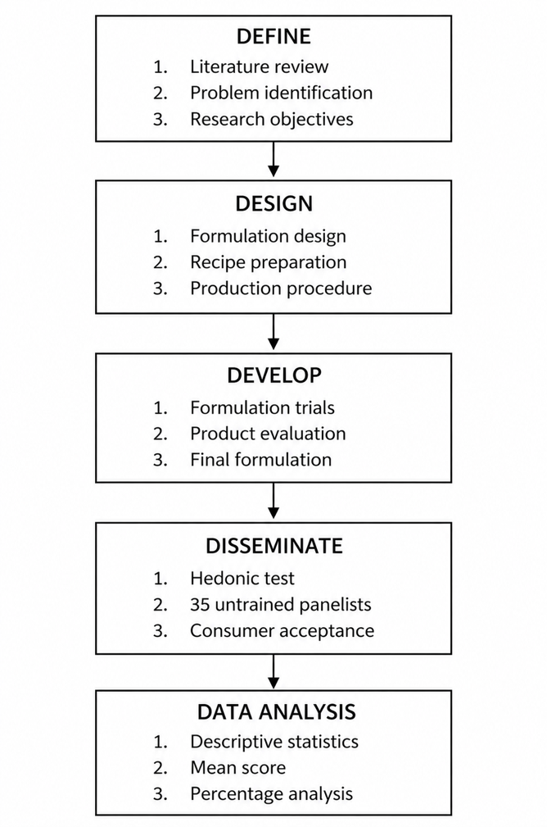

Figure 1. Research Flow Diagram
Parameswara, et al (2026)
The research was conducted at the Culinary Arts Laboratory of Politeknik Internasional Bali, Indonesia. Breadfruit (Artocarpus altilis) flour was used as the primary flour ingredient to develop brookies as an alternative gluten-free bakery product. During the Define stage, a preliminary analysis was conducted to identify the potential of breadfruit flour as a locally available alternative to imported wheat flour. Relevant literature on the nutritional characteristics, functional properties, and previous applications of breadfruit flour in bakery products was reviewed to identify the research gap and establish the objectives of product development. In addition, the desired sensory characteristics of brookies, including color, aroma, taste, and texture, were determined as the quality targets of the developed product.

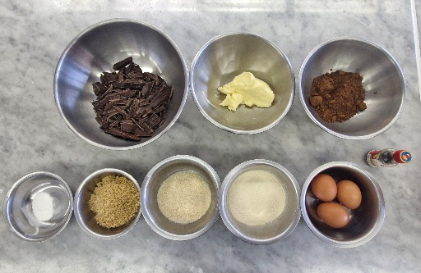

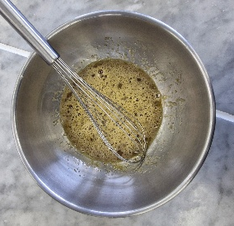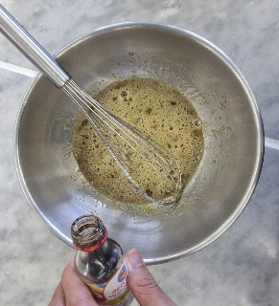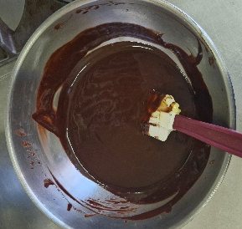

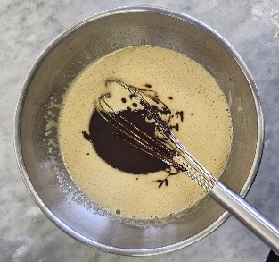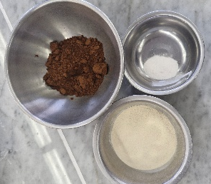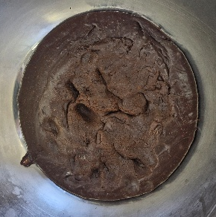

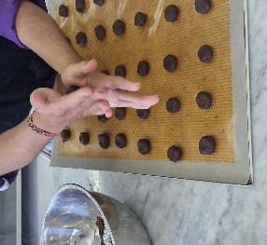

Figure 2. The Breadfruit Flour-Based Brookies Development Process
Parameswara, et al (2026)

The Design stage involved formulating the initial brookies recipe using breadfruit flour as the primary flour ingredient together with cocoa powder, compound chocolate, butter, eggs, brown sugar, granulated sugar, vanilla essence, baking powder, and salt. The production procedure, including mixing, chilling, and baking conditions, was designed based on preliminary trials and references from previous bakery product studies. At this stage, the sensory evaluation instrument using a five-point hedonic scale was also prepared.
During the Develop stage, several formulation trials were conducted to obtain the most appropriate product characteristics. Minor adjustments were made to the dough consistency and baking conditions until the desired appearance, flavor, aroma, and texture were achieved. The selected formulation was then established as the final prototype and prepared for consumer evaluation.
Finally, during the Disseminate stage, the finalized breadfruit flour-based brookies were presented to consumers for sensory evaluation using a hedonic questionnaire. This stage was intended to determine consumer acceptance and assess the feasibility of utilizing breadfruit flour in the development of hybrid bakery products.
Brookies were prepared by melting compound chocolate and butter using the double-boiler method, followed by mixing with eggs, brown sugar, granulated sugar, and vanilla essence until homogeneous. Breadfruit flour, cocoa powder, baking powder, and salt were then incorporated into the mixture without overmixing. The dough was refrigerated for approximately 60 minutes, portioned into 10 g pieces, chilled again for 10 minutes, and baked in an electric convection oven at 170–180°C for approximately 25–35 minutes until the surface became dry and developed a characteristic shiny crust. The baked products were cooled at room temperature before sensory evaluation.
Consumer acceptance was evaluated using a five-point hedonic questionnaire involving 35 untrained panelists selected through purposive sampling. The inclusion criteria required participants to be healthy, willing to participate voluntarily, free from taste or smell disorders, and not allergic to the ingredients used in the product. The questionnaire evaluated four sensory attributes : color, aroma, taste, and texture, using a five-point hedonic scale ranging from 1 (strongly dislike) to 5 (strongly like).
The collected data were analyzed using descriptive statistical methods by calculating the mean scores and percentage values for each sensory attribute. The results were subsequently interpreted using hedonic category intervals to determine the overall level of consumer acceptance toward breadfruit flour-based brookies.

Results and Discussions

Results
This section presents the findings obtained from the sensory evaluation of breadfruit flour-based brookies. The results include the demographic characteristics of the panelists, consumer acceptance through the hedonic test, descriptive sensory evaluation, and the summary of sensory characteristics. These findings provide an overview of the acceptability and sensory quality of the developed product.

Demographic Characteristics of Respondents
A total of 35 untrained panelists participated in the sensory evaluation. The respondents represented different age groups, occupations, and genders to provide diverse consumer perceptions toward the developed product.

Table 1. Demographic characteristics of respondents
Characteristics | Frequency (n) | Percentage (%)
Age
16–25 years | 19 | 54.3
26–35 years | 15 | 42.9
36–45 years | 1 | 2.9
Occupation
Student | 17 | 48.6
Staff | 14 | 40.0
Lecturer | 4 | 11.4
Gender
Male | 18 | 51.4
Female | 17 | 48.6
Total | 35 | 100

The majority of respondents were young adults aged 16–25 years (54.3%), followed by respondents aged 26–35 years (42.9%). Most participants were students (48.6%), while the gender distribution was relatively balanced between male (51.4%) and female (48.6%) respondents. This demographic composition indicates that the sensory evaluation primarily reflects the perception of young consumers, who represent one of the major target markets for innovative bakery products.

Hedonic Evaluation
Consumer acceptance of breadfruit flour-based brookies was assessed using a five-point hedonic scale covering four sensory attributes: color, taste, aroma, and texture.

Table 2. Hedonic evaluation of breadfruit flour-based brookies
Sensory Attribute | Mean Acceptance (%) | Category
Color | 76.6 | Liked
Taste | 80.0 | Liked
Aroma | 74.3 | Liked
Texture | 74.3 | Liked

The hedonic evaluation indicated that all sensory attributes were categorized as liked by the panelists. Taste achieved the highest acceptance score (80.0%), followed by color (76.6%). Aroma and texture obtained identical acceptance scores of 74.3%, suggesting that the incorporation of breadfruit flour did not negatively affect consumer acceptance.

Descriptive Sensory Evaluation
The descriptive sensory evaluation was conducted to identify the dominant sensory characteristics perceived by the panelists.

Table 3. Descriptive sensory characteristics of breadfruit flour-based brookies
Attribute | Dominant Characteristic | Percentage (%)
Color | Dark brown | 54.3
Taste | Moderately sweet | 51.4
Aroma | Strong chocolate aroma with slight breadfruit aroma | 45.7
Texture | Very crispy | 54.3

The descriptive evaluation revealed that the product was characterized by a dark brown appearance, moderately sweet taste, strong chocolate aroma accompanied by a subtle breadfruit note, and a very crispy texture. These characteristics represent the expected sensory profile of brookies while maintaining the unique properties contributed by breadfruit flour.

Discussions
The present study demonstrates that breadfruit flour can be successfully utilized as a local alternative ingredient in brookies without reducing consumer acceptance. All sensory attributes, including color, aroma, taste, and texture, were categorized as "liked," indicating that the developed formulation achieved satisfactory sensory quality. These findings are consistent with sensory evaluation theory, which states that consumer acceptance is determined by the interaction of multiple sensory attributes rather than a single characteristic. A product is considered acceptable when visual appearance, aroma, taste, and texture collectively create a pleasant eating experience (Stone et al., 2020). Therefore, the favorable hedonic scores obtained in this study indicate that the breadfruit flour formulation maintained the overall sensory balance expected in bakery products.
Taste received the highest acceptance score among all evaluated attributes. From a food science perspective, taste perception is influenced by the interaction between sweet compounds, cocoa constituents, fat, and flavor-release mechanisms during mastication. Breadfruit flour possesses a relatively neutral flavor profile with low concentrations of volatile compounds compared with many other local flours. Consequently, it does not dominate the flavor system of the product but instead functions as a supporting ingredient that allows the chocolate flavor to remain predominant. Furthermore, the presence of butter and compound chocolate contributes to flavor retention because lipids act as carriers of aroma and flavor compounds, enhancing flavor persistence during consumption. This explains why the substitution of breadfruit flour did not significantly reduce taste acceptance. Similar observations were reported by Aprilia et al. (2021), who found that appropriate levels of breadfruit flour substitution maintained favorable sensory acceptance, particularly in taste.
Color was also well accepted by the panelists. The desirable dark brown appearance can be explained by two important food chemistry reactions occurring during baking, namely the Maillard reaction and caramelization. The Maillard reaction occurs between reducing sugars and amino acids at elevated temperatures, producing melanoidin pigments responsible for the characteristic brown color and roasted flavor of baked products. Meanwhile, caramelization of sugars further intensifies the brown coloration and contributes to the glossy surface typically observed in brookies. Because breadfruit flour contains carbohydrates but relatively low protein compared with wheat flour, the presence of cocoa powder and chocolate becomes the primary contributor to browning intensity. This interaction enabled the product to maintain an appearance comparable to conventional brookies despite the absence of wheat flour. According to Hasmadi et al. (2020), composite flour formulations can maintain desirable bakery color when supported by suitable baking conditions and complementary ingredients.
The aroma profile was characterized by dominant chocolate notes accompanied by a slight breadfruit aroma. Aroma perception in bakery products is largely determined by volatile compounds generated during baking, including pyrazines, aldehydes, and ketones formed through Maillard reactions and lipid oxidation. Chocolate contains numerous volatile aromatic compounds that possess higher sensory intensity than the naturally mild aroma of breadfruit flour. As a result, the characteristic aroma of breadfruit flour became less perceptible while the desirable chocolate aroma remained dominant. This phenomenon explains why the panelists perceived the aroma as pleasant despite using a local flour as the primary ingredient. Similar findings have been reported in studies of composite-flour bakery products, where chocolate effectively improves aroma acceptance by masking undesirable notes from alternative flours.
Texture obtained a slightly lower score than taste but remained within the "liked" category. This finding can be explained by the functional properties of breadfruit flour. Unlike wheat flour, breadfruit flour does not contain gluten proteins responsible for forming the viscoelastic gluten network during dough development. Gluten contributes to gas retention, elasticity, and structural integrity in baked products. Consequently, replacing wheat flour with gluten-free breadfruit flour alters the internal structure, producing a texture that is crisp but slightly more fragile than conventional wheat-based products. In addition, breadfruit flour contains dietary fiber and starch with relatively high water absorption capacity, which influences moisture distribution during baking and contributes to the crispy exterior while maintaining a moist brownie layer. These functional properties explain why the developed brookies still exhibited the characteristic dual texture expected from this hybrid bakery product. Similar structural changes have also been described by Mayer et al. (2024), who reported that increasing breadfruit flour substitution affected texture because of the absence of gluten and the unique physicochemical properties of breadfruit starch.
Overall, the present findings demonstrate that the successful development of breadfruit flour-based brookies is not only attributable to consumer preference but also to the functional characteristics of breadfruit flour and the physicochemical changes occurring during baking. The interaction between starch gelatinization, moisture migration, Maillard browning, caramelization, and the absence of gluten collectively determined the final sensory characteristics of the product. Compared with previous studies, which primarily investigated breadfruit flour in brownies, cakes, or cookies separately, this study extends current knowledge by applying breadfruit flour in a hybrid bakery product combining brownies and cookies within a single formulation. This novelty demonstrates that breadfruit flour can be successfully incorporated into more complex bakery systems while maintaining desirable sensory quality and consumer acceptance.
From a practical perspective, these findings support the wider utilization of indigenous food resources for bakery product diversification. The incorporation of breadfruit flour contributes to reducing dependence on imported wheat flour, increases the economic value of locally available breadfruit, and promotes sustainable food innovation. For small and medium-sized bakery enterprises, the developed formulation offers a feasible strategy for producing value-added bakery products that combine local ingredients with contemporary consumer preferences, thereby strengthening the competitiveness of Indonesian local food products in the modern bakery market.

Conclusions
This study demonstrates that breadfruit (Artocarpus altilis) flour can be successfully utilized as an alternative local ingredient in the development of brookies with satisfactory sensory quality and consumer acceptance. The developed product was positively accepted in terms of color, aroma, taste, and texture, indicating that the incorporation of breadfruit flour did not adversely affect the overall quality of the bakery product. The findings highlight the potential of breadfruit flour to support food diversification through the utilization of indigenous agricultural resources while reducing dependence on imported wheat flour. Furthermore, the development of breadfruit flour-based brookies contributes to the creation of innovative bakery products with added economic value and provides practical opportunities for the culinary and bakery industries to expand the use of local ingredients.
This study has several limitations that should be considered when interpreting the findings. First, consumer acceptance was evaluated using only 35 untrained panelists, which may not fully represent broader consumer preferences. Second, the evaluation focused exclusively on sensory acceptance (color, aroma, taste, and texture), while important quality parameters such as nutritional composition, physicochemical characteristics, texture profile analysis, and shelf life were not investigated. Third, only one breadfruit flour formulation was evaluated, preventing comparisons among different substitution levels that could further optimize product quality. These limitations indicate that the findings should be interpreted as an initial evaluation of the feasibility of breadfruit flour-based brookies rather than as comprehensive product characterization.

References
AACC International. (2010). Approved methods of analysis (11th ed.). AACC International.
AOAC International. (2019). Official methods of analysis of AOAC International (21st ed.). AOAC International.
Aprilia, D., Widyastuti, N., & Rahmawati, D. (2021). Effect of breadfruit flour substitution on the sensory characteristics of sponge cake. Food Research, 5(6), 280–287. https://doi.org/10.26656/fr.2017.5(6).412
Badan Standardisasi Nasional. (2011). SNI 2973:2011 Biskuit. Badan Standardisasi Nasional.
Badan Standardisasi Nasional. (2018). SNI 01-2973-2018 Biskuit. Badan Standardisasi Nasional.
Hasmadi, M., Noorfarahzilah, M., Noraidah, H., Zainol, M. K., & Jahurul, M. H. A. (2020). Functional properties of composite flour and its application in bakery products: A review. Food Research, 4(6), 1829–1841. https://doi.org/10.26656/fr.2017.4(6).180
Kurniawan, A., & Nurhayati, S. (2023). Utilization of local flour in bakery products: Consumer acceptance and product quality. International Journal of Gastronomy and Food Science, 31, 100676. https://doi.org/10.1016/j.ijgfs.2023.100676
Mayer, A., Lestari, N. P., & Hidayat, T. (2024). Utilization of breadfruit flour in steamed brownies: Physicochemical and sensory evaluation. Food Research, 8(2), 156–165. https://doi.org/10.26656/fr.2017.8(2).1079
Muniroh, L., & Hasanah, U. (2024). Consumer acceptance of gluten-free cookies formulated from local flour. Journal of Culinary Science & Technology, 22(1), 35–49. https://doi.org/10.1080/15428052.2023.2249185
Sari, D. P., Hidayat, B., & Wulandari, E. (2022). Food diversification through the utilization of indigenous flour in bakery products: A systematic review. Foods, 11(18), 2845. https://doi.org/10.3390/foods11182845
Setyowati, R., Kusnandar, F., & Hariyadi, P. (2021). Sensory evaluation as a tool for product development in bakery products. Food Research, 5(5), 415–423. https://doi.org/10.26656/fr.2017.5(5).598
Stone, H., Bleibaum, R., & Thomas, H. A. (2020). Sensory evaluation practices (5th ed.). Academic Press.
Suhendri, D., Pratiwi, R., & Yuliana, N. (2022). Development of gluten-free brownies using local flour substitution. International Food Research Journal, 29(5), 1123–1131.
Utaminingsih, E. S., Intania, B. Y., Aida, H., Salama, M. S., & Sukma, I. M. (2024). Designing an innovative educational framework for “How We Live and Grow” using the 4D model. The Journal of Educational Development, 12(1), 42–52. https://doi.org/10.15294/jed.v12i1.2126
Widaningrum, Miskiyah, & Winarti, C. (2020). Diversification of local food based on Indonesian indigenous crops to support sustainable food security. IOP Conference Series: Earth and Environmental Science, 443, 012082. https://doi.org/10.1088/1755-1315/443/1/012082
Yulianti, E., & Santoso, U. (2023). Consumer preference toward innovative bakery products developed from local ingredients. Journal of Food Science and Technology, 60(9), 3425–3435. https://doi.org/10.1007/s13197-023-05762-4

